## horizontal line

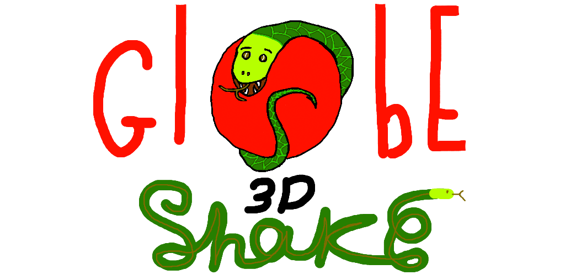

Snake World

24.07.2016

**─**

Ilia Glizerin

Wambo Ing.

# Overview

The “Snake World” is a game where a user will try to collect as many apples as he can before he hits himself and loses. It follows the idea of the classical snake game, and enhances it with 3D immersiveness, graphics, and innovation.

# Vision

Snake World should be a graphically appealing game. That runs smoothly on the lowest end device of “Samsung Galaxy S3” and its brethren. The Game should Have a basic localization system to at least these languages (Russian, English). The Game should be Stage Based, with each stage providing slightly different user experience, and a new graphical environment. The game should be able to get its graphical assets after the first initial download, so that the APK Build size will be below 50 MB. So that you won't have to use Wifi to download the game. The Game should provide basic analytics services, So that we will be able to learn and adapt to our users playing experience. Our Game will have a way to make money. The first few Stages will be free, the next stages will have to be purchased by in game purchase mechanism. Between each two playing sessions we will also advertise our other games or some foreign apps.

# Goals

1. Create a game that is fun to play. Meaning that statistically, people that try it will open it a second time.
2. Continuous Improvement. Meaning that the game will promote its updates so that users can continue playing it and experience new features.
3. Variety of gameplay options. Meaning that the game will have “Stages” where each stage will provide the users a slightly different challenge.
4. Business Intelligence. Meaning that we will know and understand our user behaviour in our game through basic Analytic service of some kind.
5. Competition. We will provide our users with scores and highscores features for them to strive to improve.
6. Making money. Will have a solid foundation of converting users to customers.

# Specifications

We will reach our vision by means of sprints, Where each sprint will have a life cycle of first planning, then implementing, uploading, and learning how the users react to our updates. Each sprint workload will be defined by a milestone. The tasks in the milestone will be listed in the Trello list. And once all sprint tasks are complete. The sprint will be ready to upload the new APK to the store.

# Milestones

## Basic Improvements and Infrastructure

* We will add a more visual representation for the snake level up. Because most people did not react very intelligently to the current level up system.
* The apple eat sound effect should be less annoying.
* We should add the ability to notify users that a new version is available for update.
* Make apples not spawn on snake body.
* Add a basic analytics service support. To know basic information about our user behaviour.
* Optimize the Batches that the apples create.

## New Sunshine Sthttps://trello.com/b/q6a3amvu/snakeage

* Create a new stage with sunshine graphics
* Create a jumping Special fruit in the new level that needs to be timed to collect.
* Create a separate personal record for each Stage
* Create a leaderboard score for each stage

## New Green World Stage

* Create a new stage with green jungle graphics
* Create a moving Special fruit in the new level that needs to be stalked to collect.
* Create an asset bundle system to download assets after game is initially downloaded

## New Water World Stage

* Create a new stage with water world graphics
* Create a moving Jumping fruit in the new level that gives the snake the ability to jump and float for a few seconds